CHRONIC PAIN IN CORWALL
“Should I try opioid painkillers?”
INFORMATION AND TREATMENT AGREEMENT

Embarking on opioids for chronic pain is risky. Sometimes there’s a benefit for a few months but there’s a high chance the drugs won’t help the pain long term.

Also there may be unpleasant side effects, potentially dangerous longer-term risks and about 10-20% of patients get dependent and even addicted to these drugs making stopping the medications difficult and painful.

If you and your prescriber are thinking about a trial of opioids for a chronic pain condition then this document is for you.
First it describes the drugs and the side effects, risks and day-to-day information. Then there is a section on when and how to reduce and stop the drugs if you’re already on them and they’re not working.
OPTIONAL EXTRA:
Finally there is the “treatment agreement” which can be used at your / your prescribers discretion. It sets boundaries that mustn’t be crossed by either patient or prescriber – and if they are then prescribing may have to stop. We’ve incorporated a “risk of dependence” calculator.

Please read and study this document carefully before prescribing.

If you do go ahead with an opioid trial we hope your quality of life improves. If it doesn’t, we hope you get off these strong dangerous drugs as quickly as possible without harm.

Dr J Huddy GP
Dr K Mitchell consultant in pain medicine
Dr A Flynn consultant in liaison psychiatry
Dr P Fortun consultant gastroenterologist

NHS Kernow Chronic Pain Taskforce
December 2017
Part 1 - Opioids for Pain Management – Patient Information

What are opioids?
Opioids are a family of strong pain killers, which includes morphine, diamorphine (heroin), fentanyl, codeine, tramadol and others. They are not suitable for all types of pain. The aim of opioid treatment is to reduce the pain so that you can do more of your daily activities, not to take away the pain completely. They should not be used in isolation but with other pain relieving medications and in combination with other activities such as exercise and distraction. Opioids should be taken with the close guidance of a healthcare professional. Care must be taken to use only the prescribed dose and to keep these medications away from children.

How effective are opioids for pain relief?

Acute (recent onset) pain: Opioids work well for acute pain such as post-operative pain or cancer related pain in combination with other analgesics because it is mainly due to tissue damage. We would expect acute pain to settle within 3 months.

Chronic (long term) pain: - not very effective. Chronic pain isn’t usually due to tissue damage, and it is rare to completely relieve it with medications. The aim of treatment is to reduce pain enough to allow you to get on with your life. On average opioids will only help about 1 in 5 people and even then pain levels are generally only reduced by about 30%. This is why we give a trial of treatment and only continue the drug if there is clear benefit.

Are there any side effects?
Opioids have many unwanted side effects. The most common include, but are not limited to: dizziness, sickness, sleepiness, confusion, itching, alteration in mood, reduced sexual drive, weight gain, opioid-induced hyperalgesia (increased pain), opioid-induced bowel dysfunction which includes; narcotic bowel syndrome, nausea, vomiting, abdominal pain and constipation. Too much can lead to reduced breathing, unconsciousness and death. There is a full list of known side effects described in the information leaflet that comes with your medication. Besides pain relief, opioids may have other effects such as euphoria (feeling good/high for a while) or dissociation (emotional numbing). These are followed by a period of “coming down” and worsening pain as the drug levels fall. If this low is managed by increasing the dose of opioid, then escalation, tolerance and increased dependence will follow.

Can I still drive?
The law in the UK currently allows you to drive if you are taking prescribed opioid medicines and are taking them according to the prescription. You should not drive if you have changed your dose or if you feel that your judgment is impaired. You are responsible for making sure you are fit to drive.

Can I drink alcohol?
Alcohol and opioids together cause sleepiness and poor concentration. Avoid alcohol completely when you first start on opioids, when your dose has just been increased or if you drive or operate machinery. When you get on a steady dose of opioid, you may be able to tolerate modest amounts of alcohol.

Are opioids addictive?

Physical dependence and/or tolerance can occur with the use of opioid medications.

Tolerance is an inevitable physiological process defined by the gradual loss of effect over time as your body gets used to the drug.

Dependence means that you may experience withdrawal symptoms if the drug is suddenly stopped; therefore the drug is gradually reduced to prevent this. This is a physiological process, which can be very uncomfortable but is not life threatening. Most people develop dependence if using opioids continuously for more than a few weeks.

Addiction is a form of psychological dependence with extreme patterns of behaviour associated with obtaining and consuming the drug. If it is felt that this is happening, the opioid will be gradually withdrawn.

Abuse is a term that means that the drug is not being used in a responsible way. If this is suspected, the prescribed opioid will be gradually withdrawn.

What is an opioid management plan?

This is a plan of care regarding the prescription of opioid analgesics. It provides patients with information to allow an informed decision regarding commencement or continuation of the drugs and stipulates goals, sets out realistic expectations and responsibilities for both patients and clinicians to minimise risk. Your GP will be responsible for on-going prescribing of your opioids and they will be responsible for ensuring the terms of this agreement are being met.
Where a patient management plan is used, this leaflet forms the patient information section of that plan

Part 2 - Weaning opioids – Advice for patients

If pain remains severe despite taking opioids, it is probable that the opioids are not helping at all and you would feel better and avoid the associated risks if you reduced or stopped them. Read the leaflet that comes with the medication (or consult the internet) for the long list of negative effects of taking opioids.

We now know that when long-term opioids are used to treat long-term pain, there can be benefit for the first few weeks of treatment, but this benefit then tails off. For the majority, opioids provide little or no pain relief in the long term, and lead to an overall reduction in their quality of life.

Most people that have been on opioids for more than a few days will experience side effects when they reduce the dose. Side effects vary in their intensity and unpleasantness. Side effects generally reduce after 3 days and are mostly gone after a week.

What are the symptoms of opioid withdrawal?

Pain is often the first. This may be general muscle and joint pain or an increase in the patient’s painful condition. Many people take these “withdrawal pains” as a sign that the opioids had been working and need to be continued (or even increased) – they are not. It can be tough getting through this time but it’s worth it.

Other side effects of withdrawal are rather like severe flu, and may include
Sweats, chills, “goose flesh”
Abdominal cramps, diarrhoea
Anxiety, insomnia, fatigue, malaise

Not everyone experiences these symptoms, but you are more likely to if you stop your opioids suddenly or reduce the dose very quickly. If you do experience severe symptoms you may need to reduce the dose more slowly. Some people occasionally need medication to control the effects of opioid withdrawal.

“But my opioids were recommended and prescribed by a doctor!”

The evidence regarding the use of long-term opioids has changed in recent years. It has become clear that in the past, doctors over-estimated the effectiveness of opioids, and under-estimated the problems associated with their use.

How can opioids be withdrawn?

The most suitable withdrawal schedule varies widely, depending on the individual, their circumstances, the drug dose and how long the drugs have been taken. Try the suggestion below, and adapt it as required.

Work out a reduction dose – the amount by which your daily dose will be reduced. A suggestion is approximately 10% of your current daily total opioid dose. It may be necessary to first change your opioid(s) to a drug or a schedule that allows this reduction, then to reduce using the new drug. Your doctor can help you with this. The pain clinic can advise. The reduction figure of 10% is only a rough guide – it may not be possible or practical to do this as tablets only come in certain sizes.

Reduce your daily intake by the reduction dose. If you possibly can, maintain this lower dose for 2 weeks. If after that time your symptoms are no worse than when you were on the higher dose, then you are ready to make your next reduction.

Reduce by the reduction dose again. Repeat the process ten times and your weaning progam is complete.

You may find that withdrawal symptoms become more prominent as you near the end of the wean. This is normal, and is not a sign that the wean shouldn’t continue. Make the dose reduction smaller, and keep going if you can.

What if withdrawal effects are intolerable?

First, try reducing in smaller steps, or prolong the period between reductions. Consider non-medical strategies – distraction and self-reward can be very effective. If this proves inadequate, your doctor might have some medication that lessens the side effects
There are organisations that help patients that are struggling to wean opioids or other medications – see your GP for details. Some information is outlined in the document “Weaning Opioids – advice to GP’s”

I’ve weaned, and I’ve still got pain. Now what?

Once you have been off opioids for a few weeks, or at least on a lower dose, consider two questions:
Has my quality of life gone up or down as a result of the wean? Why?
Has my pain increased, decreased or remained the same?
If you are not happy with the end result of weaning, speak to your doctor about your experience to discuss what to do now. Suggestions include:
Consider taking short-acting opioids instead. These should be taken only to treat exacerbations (worsening) of your pain, or before doing activity that you can’t manage without them. Evidence suggests that the less often opioids are used the more effective they are. They should not be taken more than once or twice a day.
Consider alternative pain relief. Sometimes a referral to another practitioner, such as a physiotherapist or pain clinician, might be appropriate.
Occasionally it might be appropriate to reinstate your opioids. This is rare – the majority of people feel and function better after weaning. If you and your GP do decide to go back to opioids, do so gradually in order to stave off the inevitable tolerance and reduction in benefit.

Further information...

Enclosed is a flyer to lead you to information for patients in Cornwall with chronic pain.
CHRONIC PAIN IN CORNWALL
The Treatment Agreement
(...to be filed in the patient record)

Date ____________________

This document describes a plan for the management of opioid analgesics agreed between:

Clinician ___________________________ Job title ________________________ and

Patient

Patient Declaration

In signing this agreement, I agree to the following conditions regarding the prescribing of an opioid medication:
- I have read and understood the above information about opioids and how to stop them
- My GP is responsible for prescribing a safe and effective dose of the opioid medication. My GP will control my dose, perhaps with advice from one or more hospital specialist in a condition relevant to my pain (“relevant specialist”). I will not use an opioid medication other than at the dose prescribed and I will discuss any changes in my dose with my GP.
- Any evidence of unsafe use such as: drug hoarding, acquisition of any opioid medication or other pain medication from other sources (which includes emergency departments), uncontrolled dose escalation, loss of prescriptions, or failure to follow the agreement may result in termination of the agreement and withdrawal of opioids.
- I am responsible for the security of my opioid medication at home. Lost, misplaced or stolen medication or prescriptions for opioid medicines may not be replaced. In the event that opioid medication is stolen, this must be reported to the police.
Chronic pain treatment agreement page 1

Patient name ..........................................................
- I will only obtain my opioid medication from my GP or another doctor specifically authorised by them, or a relevant specialist. I understand that no early prescriptions will be provided.
- I have read the patient information on this agreement regarding opioid analgesia and I will tell my GP or specialist if I experience on-going/intolerable side effects.
- As possible dependence is important in the management of my pain, I have informed the clinician signing this contract of any present or past dependence on alcohol or drugs that I may have had, and of any illegal activity related to any drugs (including prescription medications) in which I may have been involved.
- I am aware that giving my opioid medication to other people is illegal and could be dangerous to them.
- I understand that if my level of activity has not improved, I do not show a significant reduction in my pain, or if I fail to comply with any of the conditions listed above my opioid prescription may be changed or stopped.
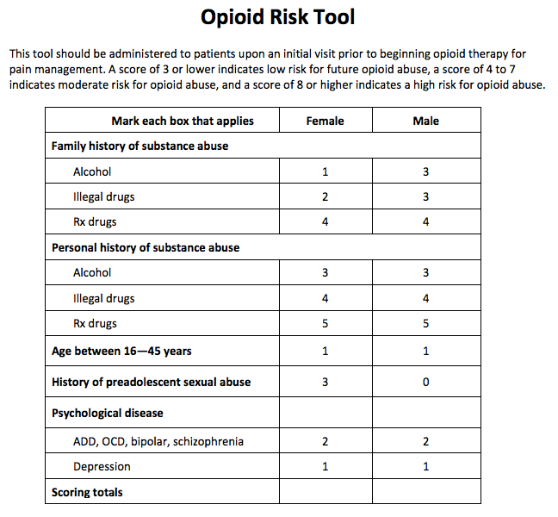
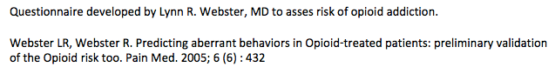
Chronic pain treatment agreement page 2
Patient name ..........................................................
Clinician section

Clinicians prescribing an opioid should have plans regarding future provision of the drug. This section allows the clinician to clarify these plans with the patient. Sections may be omitted at the prescriber’s discretion.

Healthcare Professional to complete - Sections may be omitted as appropriate.
Condition(s) being managed with opioids:

Opioids being taken prior to the implementation of this agreement (if any):

New opioids being commenced today
THIS IS FOR A TRIAL PERIOD DURING WHICH THE PRESCRIBER WILL NEED GOOD EVIDENCE OF IMPROVEMENT IN FUNCTION TO EMBARK ON LONG TERM TREATMENT
We suggest a weak opioid eg codeine or tramadol (not Sustained-Release) or
Oramorph max 30mg / 24hrs (use “as required” is better than regularly e.g. when in or when anticipating pain)

Period before next mandatory review:
(For new trials or dose adjustments, suggest 4-6 weeks. For long-term prescription, 6 months)

Chronic pain treatment agreement page 3
At the end of the trial period the patient should be reviewed and if function is improved then opioids may be considered in the longer term including regular (maximum 6 month) reviews. Consider intermittent dose reductions or drug holidays so as to demonstrate that ongoing prescriptions are clinically appropriate and beneficial.
Plan for weaning opioids, if applicable
(If the opioids are not to be weaned to zero, include an acceptable range for the on-going dose of opioids)

Is there a maximum opiate dose above which opioids are not to be escalated in the management of the condition being treated?
(A sensible ceiling dose of oral morphine equivalent dose is 60mg per day. Patients with chronic pain should not be supplied more that 120mg oral morphine per day. Trials of escalation should be reviewed after 4-6 weeks and reversed unless clear improvement in function and/or quality-of-life is perceived.)

Patient and Prescriber Declaration
We have read and understood the above information:
1. Opioids for pain management – Patient information and
2. Weaning Opioids – Advice for patients
We understand the information in the leaflets, and in this Treatment Agreement
We agree that opioid medication will be provided as laid out in these documents.

Patient’s signature: ____________________________ Date:

Patient’s name: ____________________________

Medical practitioner’s signature: _________________________ Date:

Medical practitioner’s name & role: _________________________

Chronic pain treatment agreement page 4

Pain usually alerts us to an injury, like a fire alarm alerting us to a fire.

CHRONIC PAIN IN CORNWALL
Information for patients

That’s fine – it tells our body to pay attention to the injury and make us rest and get better.

But sometimes the pain goes on after the injury has healed. Or pain comes out of the blue for no apparent reason. If it goes on for more than 3 months we call it chronic (or persistent / long term) pain. Think of it as a faulty fire alarm – alerting us to danger... except there’s no fire.

Cornwall GPs, pain specialists and, importantly, patients have teamed up to write information which includes video, audio and onward links to other resources to help you manage chronic pain yourselves (with less emphasis on medications) and reduce the impact it has on your lives.

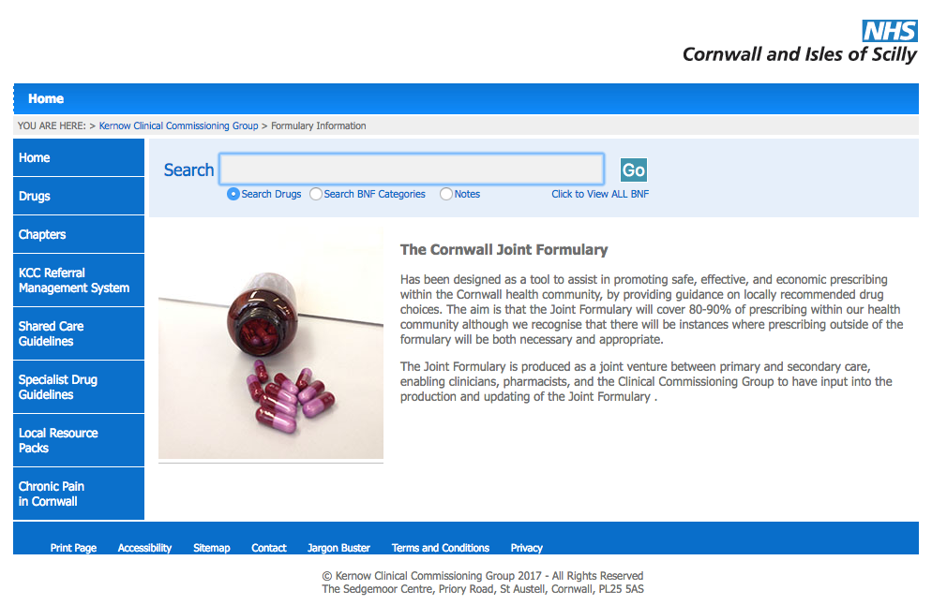
We hope you find it helpful

To find it.... go to

www.eclipsesolutions.org/cornwall

Then follow the link at the bottom
left of the page -
“Chronic pain in Cornwall”

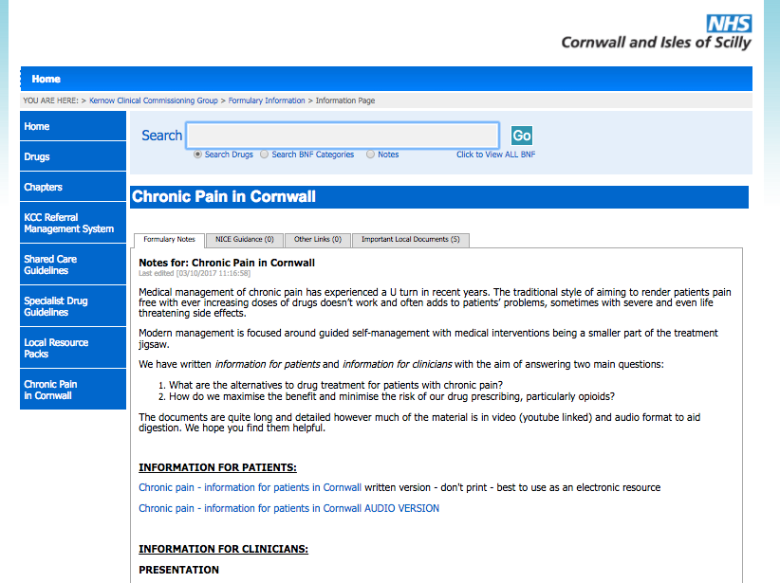

Find the “information for patients” section

